**Article ID:** 1129 New c

**Article Name:** How to clean the rubber seal of my washing machine.

**Topic Location:** Laundry / Washing machine / Cleaning & Maintenance

**Meta-data:** dirt, gasket, sleeve

**Related Articles:**

**Related Questions:**

PNC

DIY

Safety

Link

Email

Book Engineer

Multimedia

Brand

**Article Content:**

How to clean door seal or internal parts in washing machine:

This can also solve problems with marks or stains on clothes if quick wash or low temperature washing programs is used very often.

Run a number of wash cycles at 90°C, without any laundry, but with a cup of sodium carbonate (Sodium carbonate irritates skin and mucous membranes. Please use it with extreme caution!) in the drum, to clean the seal.

Or you can use our special Electrolux cleaner for washing machines:

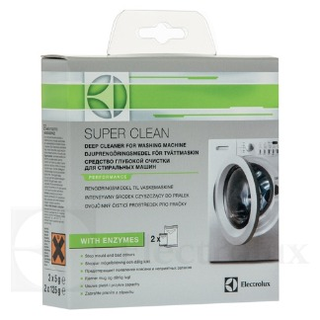

To buy this cleaner please follow the link to our webshop:

<http://shop.electrolux.co.uk/product/9029792786/Super-Clean+Washing+Machine+Cleaner>